**1.**

Question 1

**For the questions in this quiz, you will be loading images into the Image Segmenter App. In each case, when prompted to "Adjust Image?", you need to click "Yes" to get the correct results.** Use the following code to load and view an image of text data included with your version of MATLAB. Notice the illumination is very uneven.

2

imshow(textImage)





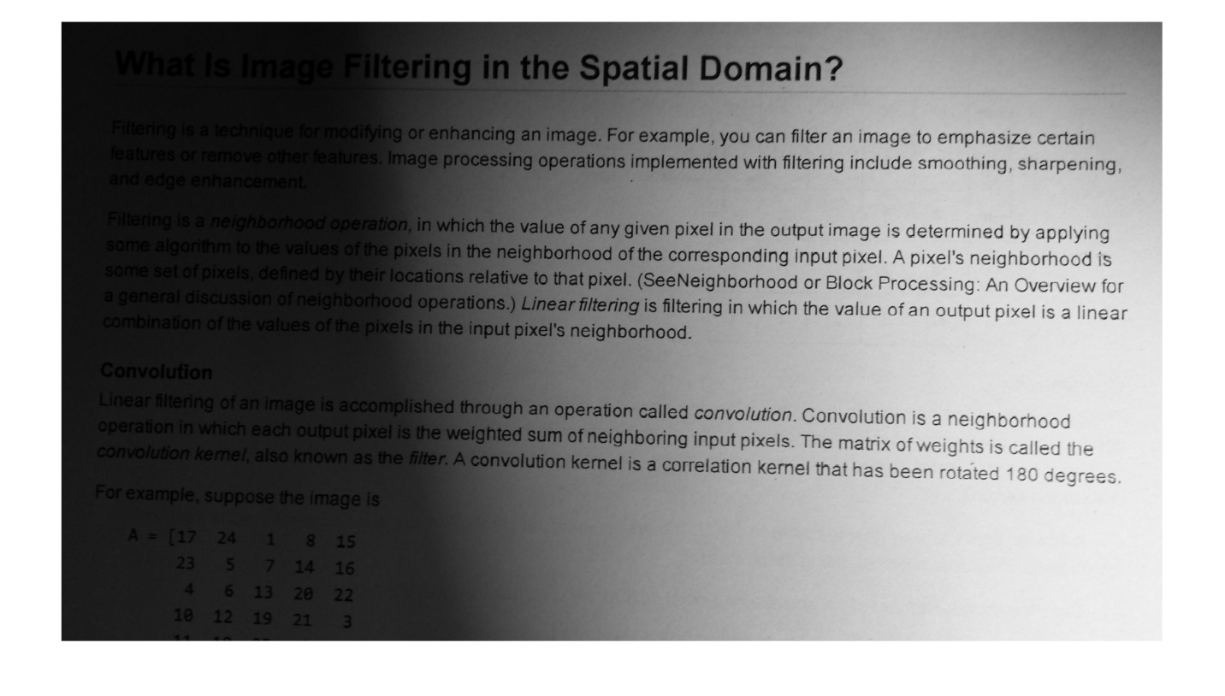

Using the Image Segmenter App, which approach below gives you the following segmented image?

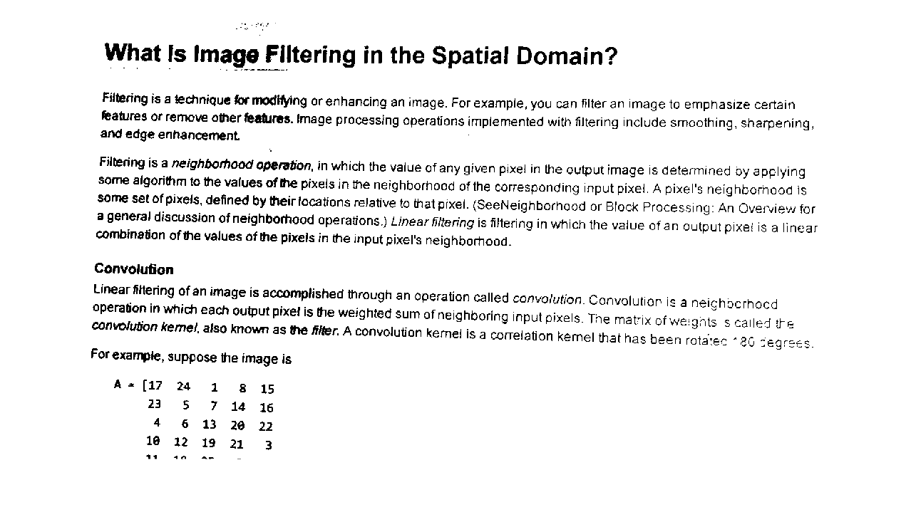

**1 / 1 point**



Adaptive threshold with a bright foreground polarity and a Sensitivity value of 50



Global Threshold



Manual threshold with a Threshold value of 60



Manual Threshold with a value of of 200



Adaptive Threshold with a bright Foreground Polarity and a Sensitivity value of 90

**Correct**

An adaptive threshold is required due to the uneven illumination. A Sensitivity value of 90 works well to separate out the text from the background.

**2.**

Question 2

Use the following code to load, convert to grayscale, and view an image of a crack included with your course files.

3

imshow(crackImage)





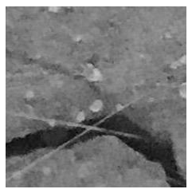

Which approach or approaches below will produce the following mask (select all approaches that work)?



**0.75 / 1 point**



1. Global Threshold
2. Invert mask
3. Close mask with a disk of radius 3
4. Open mask with a disk of radius 3



1. Global Threshold
2. Invert Mask
3. Close mask with a disk of radius 3
4. Erode mask with a disk of radius 3
5. Dilate mask with a disk of radius 3

**Correct**

Correct! Notice, erosion followed by dilation with the same structuring element is equivalent to opening.

This is one of the two correct sets of steps here.



1. Adaptive Threshold with bright Foreground Polarity and a sensitivity of 90
2. Erode mask with a disk of radius 4
3. Fill holes
4. Invert mask



1. Manual Threshold with a value of 57
2. Invert mask
3. Close mask with a disk of radius 3

You didn’t select all the correct answers

**3.**

Question 3

Use the following code to load and view an image of coins included with MATLAB.

1

2

coinImage = imread("coins.png");

imshow(coinImage)





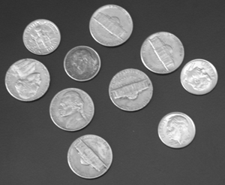

Which approach or approaches below will segment the coins as foreground with no holes, negligible missing foreground, and no extra foreground artifacts:

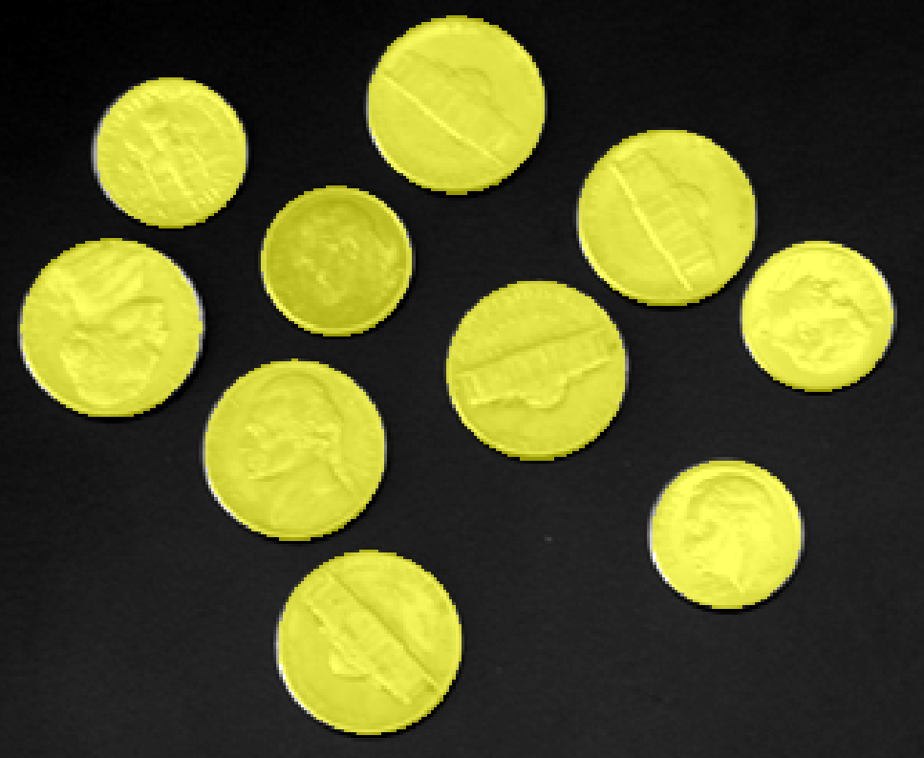

**0.75 / 1 point**



Manual Threshold with a Threshold value of 64.



Auto Cluster, then Fill Holes



Find Circles with the following settings:

* Min. Diameter: 50
* Max. Diameter: 150
* Number of Circles: Inf
* Foreground Polarity: bright
* Sensitivity: 0.85



Find Circles with the following settings:

* Min. Diameter: 30
* Max. Diameter: 150
* Number of Circles: Inf
* Foreground Polarity: bright
* Sensitivity: 0.90

**Correct**

Correct! All the coins in this image are well between 30 and 150 pixels in diameter. This is one of the two correct approaches here.

You didn’t select all the correct answers

**4.**

Question 4

Now assume you want to segment *only* the nickels (the larger of the two types of coin in this image). Can you find one or more ways that work?

**1 / 1 point**



Use the Find circles approach with a minimum diameter of 55 pixels.

**Correct**

Correct. All off the smaller coins are below this threshold and will not be included in the mask.



Choose a manual threshold of 175 to differentiate between the two types of coins.



Use Find Circles to find all the circles. Then use the "open" morphological operator with a disk shape and radius of 26.

**Correct**

Correct. Choosing a structuring element that is large enough to cover the small coins but not the large coins will remove the small coins from the mask.



Auto Cluster, then Fill Holes

**5.**

Question 5

To apply an approach developed in the Image Segmenter app on other images, the best practice is to:

**1 / 1 point**



Write down the steps you took. Load other images into the app and repeat the steps.



Load an entire folder of images into the Image Segmenter App to apply the steps to all images at once.



Generate a function from the app and apply the function to your other images.



The Image Segmenter App is meant for manual segmentation. You cannot repeat the process on other images.

**Correct**

**.**

Question 1

**For the questions in this quiz, you will be loading images into the Image Segmenter App. In each case, when prompted to "Adjust Image?", you need to click "Yes" to get the correct results.** Use the following code to load and view an image of text data included with your version of MATLAB. Notice the illumination is very uneven.

1

2

textImage = imread("printedtext.png");

imshow(textImage)







Using the Image Segmenter App, which approach below gives you the following segmented image?



**1 / 1 point**



Manual threshold with a Threshold value of 60



Adaptive Threshold with a bright Foreground Polarity and a Sensitivity value of 90



Global Threshold



Adaptive threshold with a bright foreground polarity and a Sensitivity value of 50



Manual Threshold with a value of of 200

**Correct**

An adaptive threshold is required due to the uneven illumination. A Sensitivity value of 90 works well to separate out the text from the background.

**2.**

Question 2

Use the following code to load, convert to grayscale, and view an image of a crack included with your course files.

3

imshow(crackImage)







Which approach or approaches below will produce the following mask (select all approaches that work)?



**1 / 1 point**



1. Global Threshold
2. Invert mask
3. Close mask with a disk of radius 3
4. Open mask with a disk of radius 3

**Correct**

Correct! This is one of the two correct sets of steps here.



1. Global Threshold
2. Invert Mask
3. Close mask with a disk of radius 3
4. Erode mask with a disk of radius 3
5. Dilate mask with a disk of radius 3

**Correct**

Correct! Notice, erosion followed by dilation with the same structuring element is equivalent to opening.

This is one of the two correct sets of steps here.



1. Adaptive Threshold with bright Foreground Polarity and a sensitivity of 90
2. Erode mask with a disk of radius 4
3. Fill holes
4. Invert mask



1. Manual Threshold with a value of 57
2. Invert mask
3. Close mask with a disk of radius 3

**3.**

Question 3

Use the following code to load and view an image of coins included with MATLAB.

2

imshow(coinImage)







Which approach or approaches below will segment the coins as foreground with no holes, negligible missing foreground, and no extra foreground artifacts:



**0.5 / 1 point**



Manual Threshold with a Threshold value of 64.

**This should not be selected**

Although this gets close and has no extra foreground artifacts, you should still see holes in one coin.



Auto Cluster, then Fill Holes



Find Circles with the following settings:

* Min. Diameter: 50
* Max. Diameter: 150
* Number of Circles: Inf
* Foreground Polarity: bright
* Sensitivity: 0.85



Find Circles with the following settings:

* Min. Diameter: 30
* Max. Diameter: 150
* Number of Circles: Inf
* Foreground Polarity: bright
* Sensitivity: 0.90

**Correct**

Correct! All the coins in this image are well between 30 and 150 pixels in diameter. This is one of the two correct approaches here.

**4.**

Question 4

Now assume you want to segment *only* the nickels (the larger of the two types of coin in this image). Can you find one or more ways that work?

**1 / 1 point**



Use the Find circles approach with a minimum diameter of 55 pixels.

**Correct**

Correct. All off the smaller coins are below this threshold and will not be included in the mask.



Use Find Circles to find all the circles. Then use the "open" morphological operator with a disk shape and radius of 26.

**Correct**

Correct. Choosing a structuring element that is large enough to cover the small coins but not the large coins will remove the small coins from the mask.



Choose a manual threshold of 175 to differentiate between the two types of coins.



Auto Cluster, then Fill Holes

**5.**

Question 5

To apply an approach developed in the Image Segmenter app on other images, the best practice is to:

**1 / 1 point**



Load an entire folder of images into the Image Segmenter App to apply the steps to all images at once.



The Image Segmenter App is meant for manual segmentation. You cannot repeat the process on other images.



Write down the steps you took. Load other images into the app and repeat the steps.



Generate a function from the app and apply the function to your other images.

**Correct**